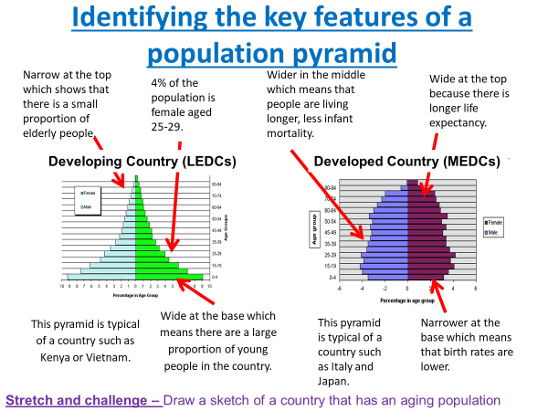

Make note of 3 differences that you can remember or would want to remember for the exam.

List it here:

1.__________________________________________________________________________

2. __________________________________________________________________________

3. ___________________________________________________________________________

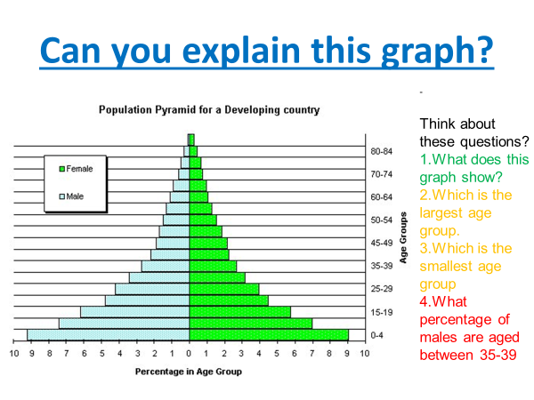

________________________________________________________________________________________________________________________________________________________________________________________________________________________________________________________________________________________________________________________________________________________________________________________________________________________________________________________________________________________________________________________________________________________________________________________________________________________________________________________________________________________________________________________________________________________________________________________________________________________________________________________________________________________________________________________________________________________________________________________________________________________________________________________________________________________________________________________________________________________________________________________________________________________________________________________________________________________________

**Population Pyramids**





